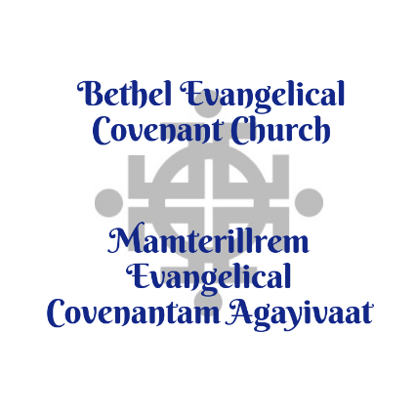
Associate Pastor of Youth and Discipleship
Bethel Evangelical Covenant Church (Bethel, Alaska)

Compensation Package: Base Salary - $36,000
Housing - $28,800 (up to)
Insurance - $15,000 (estimated)
Pension - $6,000
Travel/CEU - $3,000
Up to $88,800 annually

General Description:
To develop and oversee youth and discipleship programs of the church; introducing the lost to Christ, discipling toward spiritual growth and providing opportunities to serve in Jesus’ name.
Pastoral Functions:
- Teach and preach in various small and large group settings.
- Assist in coordinating small group discipleship ministries.
- Direct local youth outreach, mentoring, and family discipleship programs.
- Counsel and come alongside parents and families, especially in times of crisis.
- Identify youth and young adults with leadership potential and create opportunities for leadership development and discipleship.
- Develop and lead Mission opportunities locally, regionally, and globally.

Management Functions:
- Recruit, disciple, train, and supervise teams of volunteers.
- Develop and promote fundraising opportunities.
- Coordinate with and support Children’s Ministry leaders
- Perform required record-keeping and produce required reports.
- Provide information about and encourage attendance at state-wide youth activities.
- Assist with the Covenant Youth of Alaska (CYAK) annual regional youth worker training event.

Accountability
- Participate in bi-monthly CYAK meetings, annual strategic planning retreat, and monthly Church Board meetings for the purpose of connecting, resourcing, and encouragement.
- Meet regularly with the Bethel Covenant Pastor for supervision and the Pastoral Relations Committee for encouragement, accountability, and evaluation.

Spiritual Requirements:
- Demonstrate knowledge of the Bible as a consistent witness for Jesus Christ
- Pray faithfully for the ministries of Bethel Covenant Church.
- Maintain a personal plan that encourages spiritual growth, professional competency and understanding of the Evangelical Covenant Church’s ministry.
- Foster a deep appreciation for cultural differences, especially Western and Alaska Native cultures, with an understanding of how each culture has aspects that point to the Gospel Truth and every culture has aspects that need to be redeemed and transformed.

Other Requirements:
- Bachelor's or Master’s degree in Ministry preferred.
- 2-4+ years previous experience working in youth or family ministry.
- 1+ year previous supervisory experience preferred.
- Previous missionary experience, or experience working in a diverse culture, strongly preferred.
- Strong communication skills and excellent organizational skills.
- Computer and social media proficiency highly preferred.

Contact: Pastor Adam London – Adam@cyak.org – 907-625-1554

